Steps to setup Postgres:-

**step 1**

go to path "C:\Program Files\PostgreSQL\10\data" and open "pg_hba.conf" file and add entry

hostnossl all all 0.0.0.0/0 trust

as below

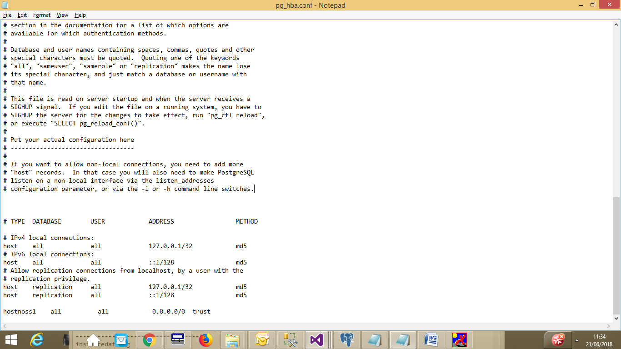

**Step 2 :-**

go to path "C:\Windows\Microsoft.NET\Framework\v4.0.30319\Config" and open "machine.config" file and below line under tag " <DbProviderFactories>"

<add name="Npgsql Data Provider" invariant="Npgsql" support="FF" description=".Net Framework Data Provider for Postgresql Server" type="Npgsql.NpgsqlFactory, Npgsql"/>

